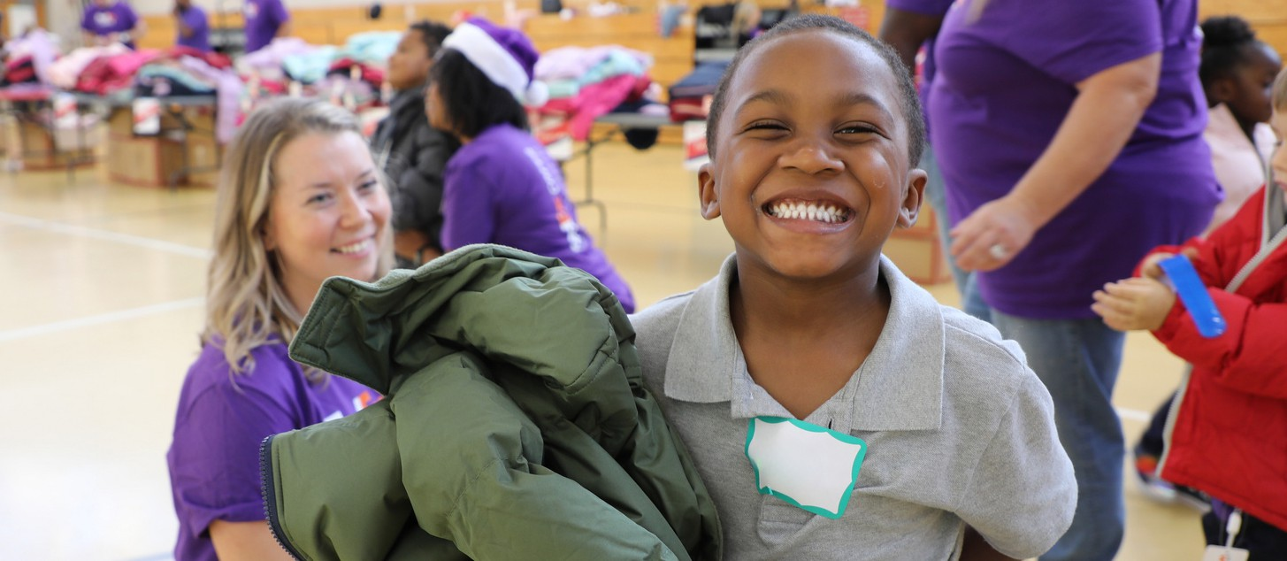





®
®
Operation Warm
Gifting Event!
To learn more visit operationwarm.org
Operation Warm, EIN 38-3663310, is a 501(c)(3) national nonprofit.

We’re excited to announce that [School Name] has been selected to host a special Operation Warm event! At this event, brand-new coats will be provided to our students, ensuring they stay warm and confident all year long.

*DATE* | *TIME*

About Operation Warm

Operation Warm believes every child deserves to feel warm, comfortable, and confident. That’s why they provide brand-new, high-quality coats and shoes to kids in need across North America. By partnering with caring individuals, local communities, and businesses, they ensure that children not only receive essential clothing but also connect to resources that help them thrive.

